Detecting Supply Chain and Dependency Confusion Attacks in Open-Source Ecosystems

Chapter 2: Literature Review

2.1 Introduction
The literature review highlights the increasing need for ensuring software supply chain security. Cox (2025) explains that with the increase in the usage of OSS and the availability of software packages such as PyPI and npm, there is an increasing trend towards the use of third-party components. Gokkaya et al. (2025) note that such reliance has resulted in security threats in software supply chains. Williams et al. (2025) list dependency confusion and typosquatting as major security threats against the open-source ecosystem. Adem et al. (2026) focus on the importance of having efficient detection techniques. This literature review focuses on reviewing current studies concerning software supply chain security, attack methods, detection methodologies, challenges, and existing research gaps, which inspire the proposed research study.

2.2 Advantages and Disadvantages of Existing Detection Approaches
Advantages
- Early Threat Detection: These metadata-based techniques allow early assessment of threats without the need to perform resource-consuming code analysis (Halder et al., 2024).
- Scalability: Automation in detection allows effective analysis of larger package archives, making it useful for bigger systems (Zhang et al., 2024).
- Improved Detection Accuracy: By using different detection tools based on risk assessment procedures, the process of recognising suspicious parcels will be improved (Wang et al., 2025).
- Enhanced Software Supply Chain Security: The current solutions will help recognise threats much quicker and make decisions about software security issues easier.
Disadvantages
- The use of metadata analysis methods may yield inaccurate outcomes due to incomplete or manipulated data on packages (Halder et al., 2024).
- Activity on repositories and the involvement of contributors may not be an accurate measure of software trustworthiness (Lew et al., 2024).
- False positives are likely to occur using similarity-based detection because such detection systems are prone to mislabeling innocent software packages as viruses (Vu et al., 2025).
- Relying on one method alone will not produce accurate results.

2.3 Open-Source Software Ecosystems and Software Supply Chain Security
Open source software (OSS) has emerged as an essential element in software development because of its potential to offer reusable software components that help speed up application development processes. According to Cox (2025), OSS environments allow the use of freely available libraries and frameworks, instead of starting from scratch while writing software. This methodology has spurred the emergence of major repository services like PyPI and npm, which function as primary portals to distribute and manage dependencies within software applications. Since companies have started relying heavily on these repositories, software supply chain management has emerged as a key part of modern software engineering.

Figure 1: Applications of Diagram Software
Source: (Cox, 2025)
This diagram provides examples of common uses of diagramming software in documentation, planning, communication, analysis, improvement, and collaboration.

2.3.1 Advantages of Open-Source Ecosystems
There are many advantages that OSS brings to the table, such as less development time, reusability of code, and lower costs of development. According to Jallow et al. (2024), the efficiency aspect is the main one, but Amft et al. (2024) state that community-driven improvements are ongoing.

Figure 2: Eight Software Supply Chain Practices
Source: (Amft et al., 2024)
The following diagram provides eight important software supply chain security practices to ensure package integrity, vulnerability management, monitoring, compliance, maintenance, and risk mitigation.
2.3.2 Disadvantages and Security Risks
The OSS ecosystem raises security risks. According to Gokkaya et al., the heavy reliance on third-party modules exposes software to vulnerabilities or the inclusion of malicious code packages. Due to external maintainers, companies may not know much about the security or reliability of their software. The lack of information on the reliability of the software can be used by attackers to distribute malware through trusted means.
Critical Discussion
With the growing adoption of OSS, there have been security risks in relation to the software supply chain. Williams et al. (2025) emphasise attacks targeting repositories, whereas Adem et al. (2026) point out that as the software supply chain becomes more complex, detecting and mitigating threats will become increasingly challenging.

2.4 Dependency Confusion Attacks
The dependency confusion attack takes advantage of flaws within dependency management systems by manipulating package managers to install malicious packages rather than legitimate ones. (Gokkaya et al., 2025) state that the dependency confusion attack happens when an attacker uploads malicious packages with names that are very close to those used by their private or organisation-specific packages. Because the package managers consider public repositories first when resolving dependencies, malicious packages can be installed by an attacker without the developer knowing about it. With the increasing use of dependency managers in businesses, dependency confusion has become a serious risk in open source projects.
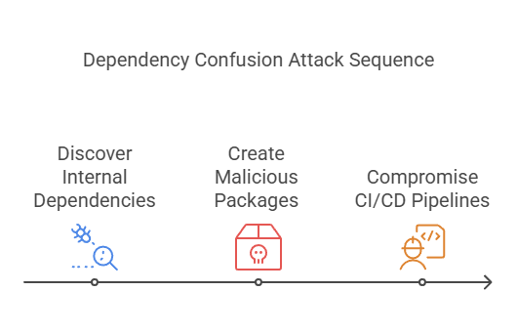
Figure 3: Dependency Confusion Attack Sequence
Source: (Gokkaya et al., 2025)
2.4.1 Advantages for Attackers
Williams et al. (2025) note that such attacks work effectively due to the ease of publishing malicious packages on public repositories. Using trusted development procedures and utilising third-party packages, a single malicious package could affect different firms, which would make the attack scalable, affordable, and hard to spot.
2.4.2 Impact on Organisations
Dependency confusion attacks can result in serious repercussions for organisations. According to Gokkaya et al. (2025), malicious software packages used in dependency confusion can cause several issues for the affected parties, such as illegal access to the system, theft of data, infection with viruses, and disruption of services. These packages are usually part of software dependencies in a secure development environment.
These attacks may cause monetary losses, a bad reputation, and non-compliance with regulations. Many different industries rely on the same dependences, the effects of such attacks become greater.
Critical Analysis
Dependency confusion attacks have been recognised by many people, but current security solutions cannot solve such problems. Adem et al. (2026) claim that due to the increasing complexity of software supply chains, software dependencies are not always authentic. The existing methods concentrate on managing vulnerabilities instead of analysing the trustworthiness of the packages, leaving gaps open for attacks on dependency resolution operations. There is a great demand for early detection tools that will help spot dubious packages in advance.

2.5 Typosquatting Attacks
A software supply chain attack called typosquatting involves creating malware packages by perpetrators with package names similar to the popular names of legitimate software packages. In Vu et al. (2025), it is stated that typosquatting takes advantage of human error as well as knowledge among developers on popular packages. As open source repositories keep growing, it is becoming more challenging to determine what packages are malicious and what are legitimate, especially when package names vary from one another by just one or two characters.
2.5.1 Common Typosquatting Techniques
There are a number of strategies that are used by hackers for the purpose of forging package names. Character omission is one such strategy that involves the omission of one letter from an existing well-known package name. The other strategy involved is that of character insertion. There is also the use of substitution, where the attackers substitute the letters with letters that resemble them. Another way they use is transposition of characters by changing their position. This type of attack relies on similarities between characters in various alphabets to come up with packages that look like the original ones.
2.5.2 Impact on Open-Source Ecosystems
Typosquatting attacks pose a risk to open-source software, as similarities in package names are used to spread malware and steal sensitive information, breaking the confidence in software repositories (Gokkaya et al., 2025). Current detection methods focus mainly on detecting known malware, where attackers keep evolving with the naming methods to avoid detection. Hence, the mechanism of automated pre-installation detection based on the similarity of package names is crucial in reducing upcoming typosquatting attacks (Vu et al., 2025; Gokkaya et al., 2025).

2.6 Metadata-Based Detection Approaches
The rapid growth of open-source repositories has made manual package inspection impractical, increasing the need for automated detection methods. Metadata-based approaches enable early identification of suspicious packages using package attributes without executing source code, making them computationally efficient and scalable for software supply chain security. These techniques support proactive risk assessment during the software development process (Halder et al., 2024; Zhang et al., 2024).
2.6.1 Package Metadata Features
Package metadata gives useful data to evaluate the trustworthiness of software without looking at source code. The package name, description, author information, release frequency, version, and download popularity are some of the features that can be used to differentiate between legitimate and suspicious packages (Halder et al., 2024). Abnormal naming conventions or anomalous update operations can be a sign of malicious behaviour, and metadata analysis can help to identify threats in the software supply chain early (Wang et al., 2025).
2.6.2 Repository Metadata Features
Metadata on repositories gives information about the development and maintenance context of software projects, in addition to package-level metadata. Features like frequency of reviewing commits, activity of contributors, maintenance of repositories, signing of packages, and governance can be used to assess the credibility and reliability of software (Lew et al., 2024; Schorlemmer et al., 2024).
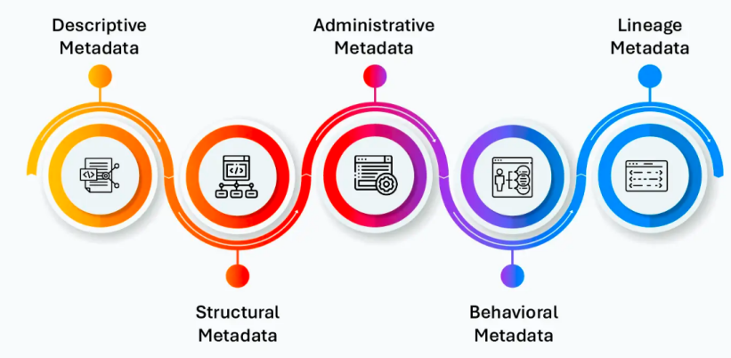
Figure 4: Types of Metadata
Source: (Lew et al., 2024)
The figure represents major metadata categories used for organising, managing, tracking, analysing behaviour, and governing data. The analysis of relationships between packages and repositories enhances the knowledge of software ecosystem risks as well (Wu et al., 2024). Metadata-based detection can be made to scale to large open-source repositories and is computationally efficient, but attackers can also use metadata to evade detection, diminishing the accuracy of single metadata features (Halder et al., 2024; Zhang et al., 2024). Combining package and repository metadata is a more thorough and precise solution towards detecting rogue packages and enhancing the security of software supply chains.

2.7 Detection Methods Used in Existing Literature
Some strategies have been suggested by researchers to identify any suspicious activity related to the package name and metadata, among other things. The strategies are concerned with the identification of malicious packages in the software supply chain within open-source ecosystems. Some of the widely used strategies will be discussed below.
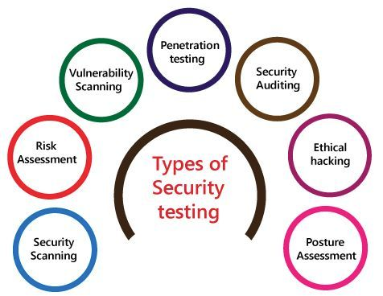
Figure 5: Types of Security Testing
Source: (Zhang et al., 2024)
This figure depicts the main security testing approaches used to discover security flaws, measure risk, analyse security control systems, and improve the security of the entire system.
Method 1: String Similarity Analysis
String Similarity Techniques are commonly employed in identifying typosquatting and package impersonation threats. According to Vu et al. (2025), string similarity techniques are used to compare strings and detect possible imitation of genuine packages by comparing package strings. Popular methods for achieving this are Levenshtein Distance, Jaro-Winkler Similarity, and many more fuzzy matching algorithms that evaluate the extent to which package names are similar. According to Halder et al. (2024), string similarity matching proves to be highly effective for the detection of such attacks. In many cases, malicious code is quite similar to the legitimate one, with just slight differences between their names, which consist of only a couple of characters.
Method 2: Metadata Analysis
The study of metadata is geared towards analysing the characteristics of the packages, looking out for anything suspicious. Halder et al. (2024) have shown how attributes of metadata, like the names of the packages, authors, releases, description, and download rates, can be helpful. In the same way, Zhang et al. (2024) point out that analysing the metadata characteristics of packages allows differentiation between benign and potentially malicious packages without the need to run any source code. It should be noted that metadata is easily accessible from package repositories.
Method 3: Repository Analysis
Repository analysis assesses the reliability of software based on repository-specific metrics, such as activity of contributors, history of maintenance, frequency of commits, package signing, and governance (Lew et al., 2024; Schorlemmer et al., 2024). The study of the connections between packages and their repositories can offer useful background on the risks of a software ecosystem, and it can enhance the understanding of the reliability of specific packages (Wu et al., 2024).
Method 4: Risk Scoring Approaches
Risk scoring systems use multiple indicators for determining how likely it is for the package to be a threat to the security of the repository. According to Gokkaya et al. (2025), risk scoring systems take into consideration many different factors in order to generate the overall risk score. Wang et al. (2025) also show that using various features together will be beneficial in enhancing the accuracy of detecting the threat since less dependency would be placed on each indicator individually.
Comparative Evaluation and Critical Discussion
The current detection techniques have their advantages and disadvantages. String similarity is effective in detecting typosquatting but is unable to detect other forms of attack, whereas metadata analysis is scalable, but can be manipulated (Vu et al., 2025). Repository analysis enhances the assessment of trust and risk scoring, which combines several indicators to be more accurate. As a result, the combination of these methods will offer an integrated system to identify malicious packages (Lew et al., 2024; Wang et al., 2025).

2.8 Challenges in Existing Research
Challenge 1: Large Package Ecosystems
The fast growth of repositories of open-source projects has led to numerous issues regarding software supply chain protection. According to Zhang et al. (2024), there are currently millions of packages in repositories like PyPI and npm. Ensuring the security of such a large number of items becomes increasingly difficult.
Challenge 2: Metadata Manipulation
Methods that involve using metadata are highly dependent on package data. Halder et al. (2024) observe that the attacker may deliberately tamper with the fields of the metadata by using a name, description, and author that are similar to those of genuine software.
Challenge 3: False Positives
The problem of false positives is very relevant for identifying malicious packages. As mentioned by Vu et al. (2025), there is a chance that packages similar in name to malware may be considered malware, causing an unwanted alert and extra work for analysts.
Challenge 4: False Negatives
The threat posed by a false negative may be even greater. According to Wang et al. (2025), highly sophisticated adversaries continually evolve methods to circumvent current detection systems, enabling malware to operate undetected.
Challenge 5: Dataset Imbalance
Another problem relates to an imbalance in datasets. As pointed out by Zhou et al. (2024), malicious packages make up a relatively smaller percentage of packages, and this adversely affects the efficacy and effectiveness of detection models.
Challenge 6: Limited Repository Information
Repository-based analysis relies on accurate data being available from the repository. According to Wu et al. (2024), data from the repository may not always be complete, up-to-date, and available.
Challenge 7: Evolving Attack Techniques
Software supply chain attacks are changing very quickly. Williams et al. (2025) note that attackers constantly change their approaches to circumvent security defences, whereas Adem et al. (2026) stress that the ability to detect such attacks requires adaptable methods to counter new challenges.

2.9 Literature Gaps and Research Contribution
Gap 1: Limited Pre-Installation Detection for Dependency Confusion Attacks
Zhang et al. (2024) identify malicious packages based on the semantics of the static code and dynamic runtime behaviour, which involves analysing code post-acquisition of packages. However, there is a limited study on detecting suspicious packages prior to installing them based on package metadata, repository metadata, and package name similarity. This paper fills this knowledge gap by suggesting a pre-installation system to pre-detect dependency confusion and typosquatting attacks.
Gap 2: Package Metadata Analysed Independently
A number of works based on metadata detection techniques have been attracting much research interest due to their efficiency and scalability. Halder et al. (2024) mainly concentrate on the metadata characteristics of packages. These metrics have value; package metadata alone might not be enough to gauge software trustworthiness. Insufficient inclusion of data from repositories is a critical weakness in the present literature.
Gap 3: Limited Risk Scoring Frameworks
Risk assessments have a significant impact on the security of software supply chains. According to Gokkaya et al. (2025), many current methodologies are based on separate indicators as opposed to risk assessment processes.
Developers and security researchers will face difficulty in understanding and prioritising security threats. Lack of any practical method for risk scoring makes current security detection systems less effective.
Gap 4: Limited Practical Implementation
While there has been growing research into software supply chains' security problems, there is a considerable amount of literature that fails to move beyond purely theoretical concepts. According to Williams et al. (2025), much existing research tends to discuss various attacks, threats, and proposals for tackling the issue without developing any actual detection tools.
Gap 5: Lack of Visualisation Support
Most current detection techniques typically output their findings through technical reports and/or classifications. According to Wang et al. (2025), insufficient visualisation abilities might lower the readability of security evaluations by developers and security experts. As a result, package vulnerabilities could be more difficult to understand and handle. The proposed research project tries to overcome these deficiencies by concentrating solely on attacks related to dependency confusion and typosquatting attacks in open-source communities. This differs from existing work, since it integrates both package-level metadata and repository-level metadata to evaluate package trustworthiness. The research includes a scoring system that helps with threat assessment and visualisation through Streamlit. The proposed framework in the research is more applicable and efficient for use in ensuring software supply chain security.

2.10 Conceptual Framework
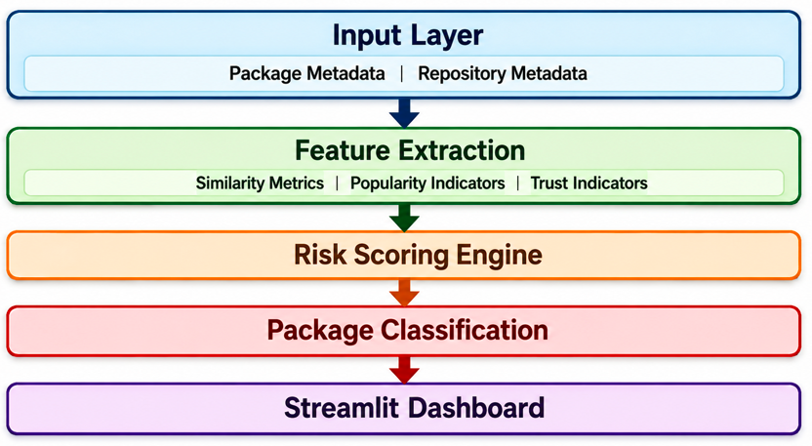
Figure 6: Conceptual Framework Image
The suggested framework identifies suspicious packages by combining package and repository metadata, extracting security features, calculating similarity and trust measures, generating risk scores, and classifying risk levels of packages. Findings are in the form of an interactive Streamlit dashboard to provide a good pre-installation security assessment and decision-making.

Chapter 3: Methodology

3.1 Introduction
This chapter presents the methodology adopted to design, implement, and evaluate a machine learning framework for detecting malicious Python packages before installation. The proposed methodology combines metadata analysis, typosquatting similarity detection, supervised machine learning, and a web-based prediction interface to identify potentially malicious packages published on the Python Package Index (PyPI). The research process begins with the collection of legitimate package metadata from PyPI, followed by the generation of synthetic typosquatting package names for model development. To strengthen the reliability of the evaluation, an independent set of real malicious Python packages obtained from the OpenSSF Malicious Packages repository was used for external validation. The chapter describes the research design, dataset construction, feature engineering, model development, evaluation strategy, dashboard implementation, and ethical considerations that guided the development of the proposed detection framework.

3.2 Research Design
This research adopted a quantitative experimental research design to develop and evaluate a machine learning framework for detecting malicious Python packages before installation. A quantitative approach was selected because the study relies on measurable package metadata, feature extraction, and statistical evaluation of classification performance using metrics such as accuracy, precision, recall, and F1-score. The experimental design enabled different supervised machine learning algorithms to be trained, tested, and compared under identical conditions to identify the most effective detection model. The research followed a structured workflow comprising data collection, feature engineering, data preprocessing, model development, model evaluation, external validation, and dashboard implementation. This systematic methodology ensured that the proposed framework could be evaluated objectively while providing reproducible results. The selected research design aligns with the project objective of developing a practical and reliable pre-installation detection system for identifying potentially malicious Python packages.
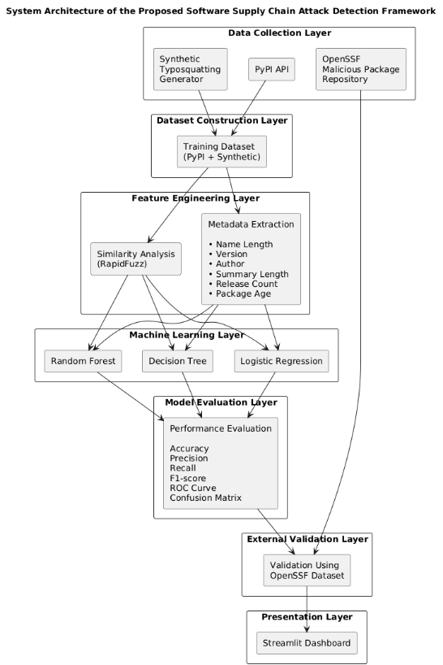
Figure 1: System Architecture

3.3 Data Collection
The performance of machine learning models depends heavily on the quality and diversity of the training data. Therefore, this study adopted a multi-source data collection strategy to construct a representative dataset for detecting malicious Python packages. The data collection process combined legitimate package metadata, synthetically generated typosquatting packages, and real malicious packages obtained from a public security repository. This approach enabled the proposed framework to learn patterns associated with suspicious packages while also supporting independent validation using real-world malicious samples.

3.3.1 Collection of Legitimate PyPI Packages
Legitimate Python package information was collected directly from the Python Package Index (PyPI) using the official PyPI Application Programming Interface (API). A list of widely used Python packages from different application domains, including web development, machine learning, data analysis, and scientific computing, was selected to represent trusted software packages. For each package, metadata including the package name, version, author, summary description, release history, and publication information was retrieved automatically using Python scripts. These metadata attributes formed the basis for subsequent feature engineering and machine learning model development.

3.3.2 Generation of Synthetic Typosquatting Packages
As publicly labelled malicious package datasets are limited, synthetic typosquatting packages were generated to simulate common software supply chain attacks. Variations of legitimate package names were created by introducing character insertion, deletion, duplication, and substitution operations that imitate real typosquatting techniques. The similarity between legitimate and generated package names was calculated using the RapidFuzz library, and highly similar package names were labelled as suspicious. These synthetic samples were combined with the legitimate PyPI packages to construct the training dataset used for supervised machine learning.

3.3.3 Collection of OpenSSF Malicious Packages
To address the limitation of relying solely on synthetic data, an additional dataset of documented malicious Python packages was collected from the OpenSSF Malicious Packages repository. These packages were not included during model training. Instead, they were reserved exclusively for external validation after model development. The same feature extraction process was applied to these packages before prediction, enabling the trained model to be evaluated on previously unseen real-world malicious samples. This external validation improved the credibility of the experimental evaluation and addressed the risk of assessing the model only on synthetically generated attack patterns.

3.4 Dataset Description
The dataset used in this research was constructed by combining legitimate Python package metadata collected from the Python Package Index (PyPI) with synthetically generated typosquatting package names. The legitimate packages represented trusted software commonly used across domains such as machine learning, web development, data analysis, and scientific computing. Synthetic malicious package names were generated by applying common typosquatting techniques, including character insertion, deletion, duplication, and substitution, to simulate attacks that imitate legitimate package names.
Each package record was represented using metadata and similarity-based features that could be obtained before package installation. These included the package name, similarity score, name length, summary length, release count, and package age in days. The target variable was binary, where legitimate packages were labelled as 0 and suspicious packages were labelled as 1. This binary labelling enabled the problem to be formulated as a supervised classification task.
In addition to the training dataset, an independent collection of real malicious Python packages was obtained from the OpenSSF Malicious Packages repository. Unlike the synthetic dataset, these packages were not incorporated into model training. Instead, they were reserved exclusively for external validation to assess the ability of the trained model to identify previously unseen malicious packages. This separation between training and validation datasets reduced evaluation bias and provided a more realistic assessment of the proposed detection framework.
Dataset | Source | Purpose | Label
Legitimate Packages | PyPI API | Model Training | 0
Synthetic Typosquatting Packages | Generated from PyPI Packages | Model Training | 1
Real Malicious Packages | OpenSSF Repository | External Validation | 1

3.5 Feature Engineering
Feature engineering was performed to transform the collected package metadata into meaningful numerical features suitable for supervised machine learning. The objective was to capture characteristics that could differentiate legitimate Python packages from potentially malicious or typosquatting packages before installation.
The first feature was the Similarity Score, which measured the similarity between a legitimate package name and a suspicious package name using the RapidFuzz library. This feature was designed to identify typosquatting attacks, where malicious packages imitate trusted package names by making small character modifications. Higher similarity scores indicate a greater likelihood that a package is attempting to impersonate a legitimate package.
Additional metadata-based features were extracted from the PyPI API. Name Length represented the number of characters in the package name, while Summary Length measured the length of the package description. Release Count captured the number of published versions, providing an indication of package maintenance and development history. Package Age (Days) was calculated from the package release date to represent the maturity of the software package.
These engineered features were combined into a structured feature set used as input for the machine learning models. By relying solely on metadata available before installation, the proposed framework supports early detection of suspicious packages without requiring source code analysis or package execution.

3.6 Risk Scoring Framework
The proposed framework employed a feature-based risk scoring approach to assess the likelihood that a Python package exhibits malicious characteristics before installation. Instead of relying on predefined rules or manually assigned risk values, the framework represented each package using a combination of engineered features extracted during the feature engineering stage. These included the similarity score, name length, summary length, release count, and package age. Collectively, these features described the package's risk profile by capturing characteristics commonly associated with typosquatting and suspicious package behaviour. The resulting feature vector was supplied to the supervised machine learning models, which automatically learned the relationship between these features and the target class during training. Packages with feature patterns resembling malicious or typosquatting behaviour were assigned a higher likelihood of being classified as suspicious. This automated risk scoring framework provided a consistent, objective, and scalable approach for supporting pre-installation detection of potentially malicious Python packages.

3.7 Data Pre-processing
Data preprocessing was performed to prepare the constructed training dataset for supervised machine learning. The training dataset, comprising legitimate PyPI packages and synthetic typosquatting packages, was first examined for missing or inconsistent values. Any incomplete metadata fields were assigned appropriate default values to ensure consistency across all records. The selected numerical features included Similarity Score, Name Length, Summary Length, Release Count, and Package Age (Days), as these represented measurable indicators of package characteristics. Textual attributes such as package names, version information, and author details were retained for reference but were excluded from the machine learning feature set. The processed dataset was then divided into input features and binary class labels representing legitimate and suspicious packages. Finally, the dataset was split into training and testing subsets using an 80:20 ratio, enabling objective model evaluation while reducing the likelihood of overfitting and ensuring reliable performance on previously unseen data.

3.8 Machine Learning Model Development
The proposed software supply chain attack detection framework is based on machine learning. A supervised learning approach was considered because the dataset has labelled examples of legitimate and suspicious packages (Lew et al., 2024). The machine learning data were the numerical features that were obtained in the feature engineering phase, such as SimilarityScore, NameLength, SummaryLength, ReleaseCount, and PackageAgeDays. These characteristics acted as input variables, and the package label was the target variable. Three machine learning algorithms were chosen to be evaluated: Logistic Regression, Decision Tree, and Random Forest. These models were selected as they are the representatives of various classification methods and are also frequently applied in cybersecurity and anomaly detection studies.
Logistic Regression: A baseline classification model chosen was Logistic Regression. It is often applied to binary classification issues and serves as a simple benchmark to compare to more sophisticated models.
Decision Tree: Decision Tree was chosen because it has the ability to model non-linear relationships and gives interpretable classification rules. The model is able to pinpoint significant decision routes that help in classifying a package.
Random Forest: The main classification model was chosen to be a Random Forest. Being an ensemble learning method, it gathers several decision trees together to enhance the predictive capabilities and to decrease the chances of overfitting. Random Forest can also determine the importance of features, which can be used to interpret the results of the classification.
Training and comparison of models: The data was separated into training and test groups in an 80:20 proportion. The models were trained using the training dataset, and the independent evaluation was conducted using the testing dataset.
The three algorithms were trained with the same data set and tested under the same conditions. Accuracy, precision, recall, F1-score, and confusion matrix were used to compare their performance. The most successful model was chosen to be integrated into the final detection framework and Streamlit dashboard.

3.9 Evaluation Metrics
The performance of the machine learning models was evaluated with the help of various evaluation metrics, which are typically used in classification problems. Multiple metrics give a more detailed evaluation of the performance of the model as compared to solely using the overall accuracy.
Accuracy: Accuracy is the percentage of correctly classified cases in comparison to the total number of observations. It gives an overall idea of the model's performance, and it is computed by dividing the correct predictions made by the total number of predictions made.
Precision: Precision is a measure of the fraction of packages that are suspected of being suspicious that are suspicious. Precision should be high because it minimises the false positive classifications and security investigations that are not necessary.
Recall: Recall is a measure of how effectively a model is able to detect suspicious packages. It is determined as the ratio of the real suspicious packages that the model successfully detects. Recall is especially a crucial aspect in the context of cybersecurity applications because the inability to detect malicious packages can leave systems vulnerable to security threats.
F1-Score: The F1-Score integrates both precision and recall into one. It gives a fair measure of the performance of the classification and is very handy when there are no perfectly balanced class distributions.
Confusion Matrix: Model predictions and classification results were visualised with a confusion matrix. The confusion matrix shows the true positives, true negatives, false positives, and false negatives and gives extensive information on the model behaviour and errors in classification.
These evaluation measures create an overall approach to comparing machine learning algorithms and finding the most efficient model for supply chain attack detection.

3.10 External Validation Using OpenSSF
To improve the reliability of the proposed framework, an external validation experiment was conducted using real malicious Python packages obtained from the OpenSSF Malicious Packages repository. Unlike the synthetic typosquatting dataset used during model training, these packages represent documented real-world malicious software identified by the open-source software security community. A random sample of 100 malicious packages was selected for validation. The same feature extraction pipeline used during model development was applied to these packages to ensure consistency. The trained Decision Tree model was then used to classify the unseen samples without further retraining. This independent validation assessed the model's ability to generalise beyond the synthetic training data and addressed the limitation of relying solely on artificially generated attack samples. The external validation provided additional confidence in the practical applicability of the proposed pre-installation detection framework.

3.11 Streamlit Dashboard Development
A Streamlit-based web application will developed to demonstrate the practical implementation of the proposed detection framework. The dashboard provides a user-friendly interface through which users can enter package information and obtain real-time predictions from the trained machine learning model. The application consists of three main components: a home page describing the project, a prediction page for malicious package detection, and a dataset analytics page presenting key visualisations and statistics. The best-performing Decision Tree model was integrated into the application using a serialized model file, enabling efficient prediction without retraining. This dashboard demonstrates how the proposed framework can support software developers and security analysts in identifying suspicious Python packages before installation.

3.12 Ethical Considerations
This research used publicly available package metadata from the PyPI API and documented malicious package information from the OpenSSF repository. No malicious packages were downloaded or executed during the study, ensuring a safe research environment. The proposed framework is intended solely for defensive cybersecurity research and aims to support the early identification of potentially malicious software packages while promoting responsible use of open-source software.

Chapter 4: Experimental Results and Evaluation

4.1 Dataset Construction Results
The dataset used in this study was constructed from three different sources. First, metadata from 98 popular Python packages was collected from the PyPI repository to represent legitimate packages. Second, typosquatting techniques were applied to generate suspicious package variants. A total of 935 synthetic package names were generated, of which 704 packages were classified as high-risk based on a similarity score threshold of 85%. Finally, 11,424 real malicious packages were collected from the OpenSSF malicious package repository and reserved for external validation.
The final training dataset consisted of 802 records, including 98 legitimate packages and 704 suspicious packages.
Table 4.1 Dataset Composition
Dataset Source | Number of Records | Purpose
Legitimate PyPI Packages | 98 | Training and testing
High-Risk Suspicious Packages | 704 | Training and testing
OpenSSF Malicious Packages | 11,424 | External validation
Final Training Dataset | 802 | Model development
Initially, 935 typosquatting variants were generated. After applying a similarity threshold of 85%, 704 high-risk suspicious packages were retained for model development
The class distribution of the final dataset is shown in Figure 4.1. The dataset is imbalanced, with suspicious packages representing the majority class. Therefore, SMOTE was applied during the preprocessing stage to balance the classes before model training.

4.2 Exploratory Data Analysis

4.2.1 Label Distribution
This analysis examines the distribution of legitimate and suspicious packages in the final dataset. The results indicate that suspicious packages represent the majority class, resulting in a class imbalance problem. Therefore, SMOTE was later applied during preprocessing to balance the dataset.
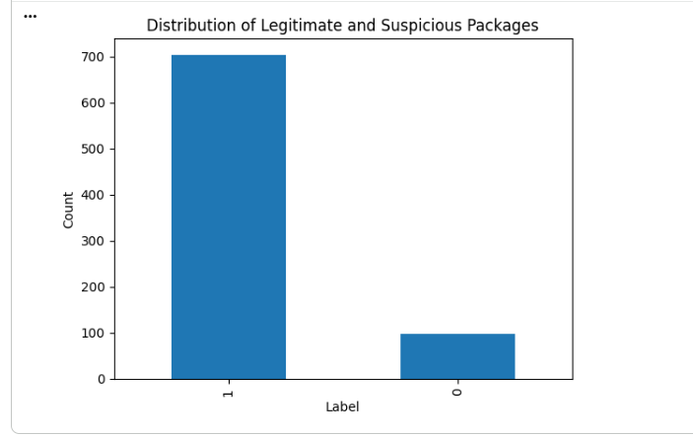
Figure 4.1: Distribution of package labels.

4.2.2 Similarity Score Distribution
The similarity score distribution illustrates how closely suspicious package names resemble legitimate package names. Most suspicious packages have high similarity scores because attackers often create package names that differ by only a few characters from popular packages.
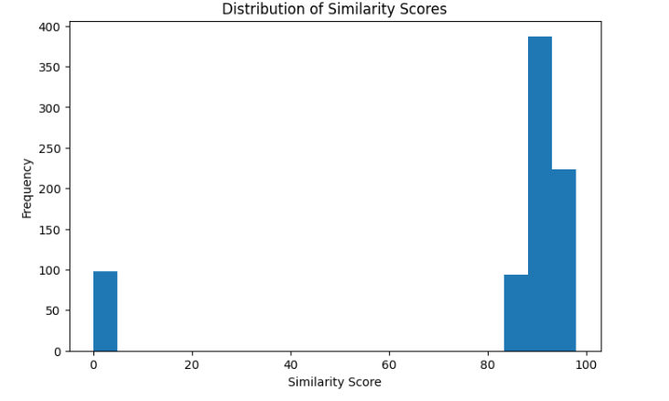
Figure 4.2: Distribution of similarity scores.

4.2.3 Summary Length Distribution
Figure 4.4 presents the distribution of package summary lengths. The histogram shows a positively skewed distribution, where most packages have relatively short descriptions and only a few packages contain substantially longer summaries. This variation suggests that package summary information may contribute to the identification of suspicious packages.
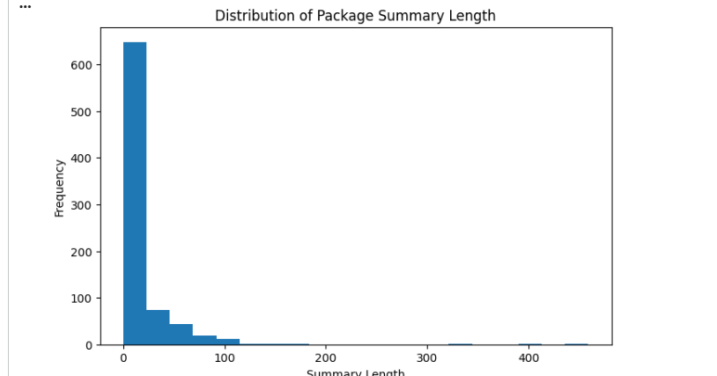
Figure 4.3: Distribution of package summary lengths.

4.2.4 Correlation Analysis
A correlation heatmap was generated to examine the relationships between the numerical features used in this study, including SimilarityScore, NameLength, SummaryLength, ReleaseCount and PackageAgeDays. Understanding these relationships helps identify potentially important features and determine whether strong correlations exist between variables.
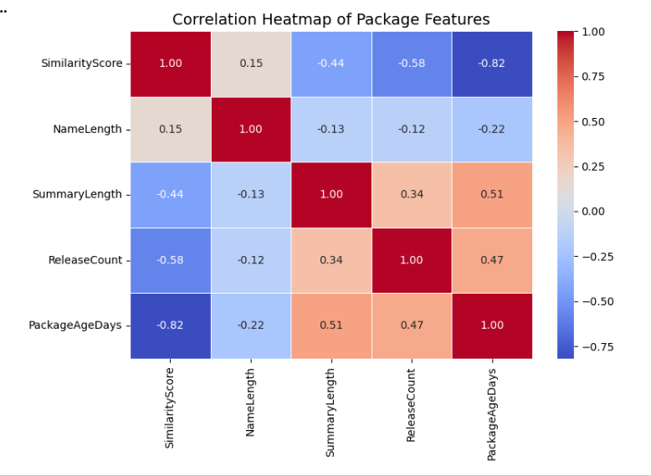
Figure 4.4: Correlation heatmap of numerical features.

4.3 Data Pre-processing Results

4.3.1 Missing Value Analysis
Before model development, the dataset was examined for missing values to ensure data quality and consistency. The analysis showed that no missing values were present in the selected features, and therefore no imputation techniques were required.
Table 4.2: Number of missing values in each feature.
Feature | Missing Values
SimilarityScore | 0
NameLength | 0
Version | 0
Author | 0
SummaryLength | 0
ReleaseCount | 0
PackageAgeDays | 0
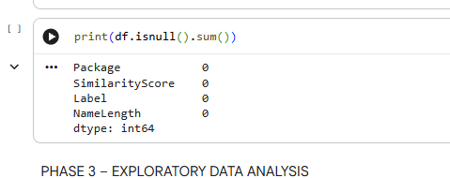
Figure 4.6: Missing value analysis.

4.3.2 Train-Test Split
The dataset was divided into training and testing sets using an 80:20 ratio. A total of 641 samples were used for model training, while 161 samples were reserved for testing and evaluation.
Table 4.3: Train-Test Split Results
Dataset | Number of Samples
Training Set | 641
Testing Set | 161
Total | 802
The class distributions before resampling are shown in Table 4.4.
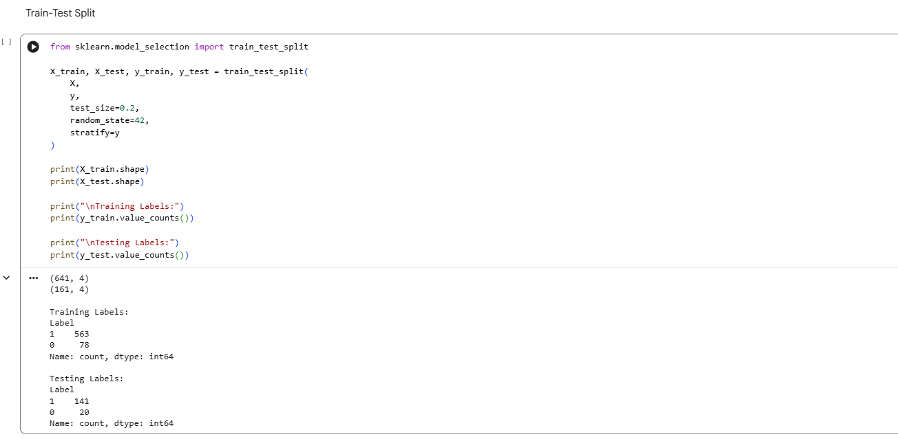
Table 4.4: Class Distribution Before SMOTE
Class | Training Set | Testing Set
Suspicious Packages (1) | 563 | 141
Legitimate Packages (0) | 78 | 20
Total | 641 | 161

4.3.3 SMOTE Class Balancing
The training dataset exhibited a significant class imbalance, with suspicious packages greatly outnumbering legitimate packages. Such imbalance can bias machine learning models towards the majority class and reduce their ability to correctly identify legitimate packages.
To address this issue, the Synthetic Minority Over-sampling Technique (SMOTE) was applied to the training dataset. SMOTE generates synthetic examples of the minority class, resulting in a balanced dataset for model training.

Table 4.5: Class Distribution Before and After SMOTE
Class | Before SMOTE | After SMOTE
Suspicious Packages (1) | 563 | 563
Legitimate Packages (0) | 78 | 563
Total | 641 | 1126
The application of SMOTE increased the number of legitimate package samples from 78 to 563, producing a balanced training dataset containing 563 samples in each class. This balanced dataset was subsequently used for training the machine learning models.
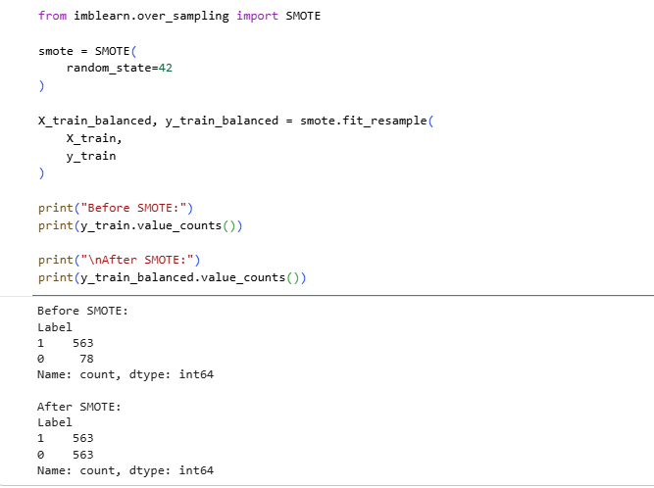
Figure 4.7: Class distribution before SMOTE and after SMOTE.

4.3.4 Feature Scaling
Before training the machine learning models, feature scaling was performed using the StandardScaler algorithm from Scikit-learn. Standardisation transforms the numerical features so that they have a mean of zero and a standard deviation of one. This process helps improve the performance and convergence of machine learning algorithms, particularly Logistic Regression.
The scaler was fitted on the balanced training dataset and subsequently applied to the testing dataset to avoid data leakage.
The dimensions of the scaled datasets are shown in Table 4.6.

Table 4.6: Dimensions of the Scaled Datasets
Dataset | Shape
Scaled Training Set | (1126, 4)
Scaled Testing Set | (161, 4)
The scaled training dataset contained 1,126 samples following the application of SMOTE, while the testing dataset contained 161 samples.
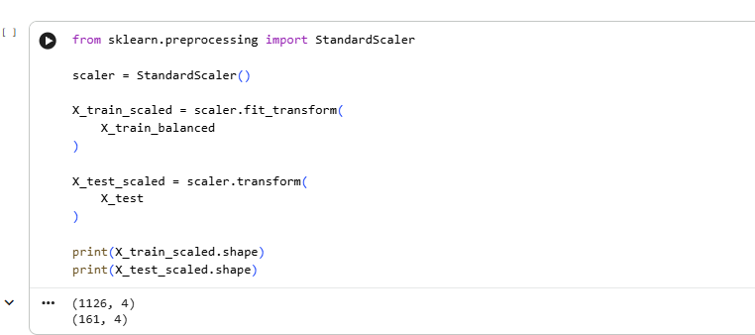
Figure 4.9: Feature scaling implementation and output.

4.4 Machine Learning Model Results

4.4.1 Logistic Regression
Logistic Regression was implemented as a baseline classification model to distinguish between legitimate and suspicious packages. The model was trained using the balanced and standardised training dataset and evaluated on the testing dataset.
Table 4.7: Logistic Regression Performance
Metric | Value
Accuracy | 96.27%
Precision | 99.27%
Recall | 96.45%
F1-Score | 97.84%
The model achieved an accuracy of 96.27% and an F1-score of 97.84%, indicating that metadata and similarity features are effective for identifying suspicious packages.
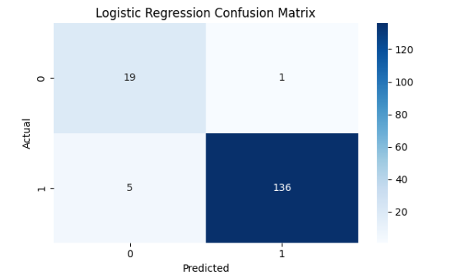
Figure 4.10: Confusion matrix of the Logistic Regression model.

4.4.2 Decision Tree
The Decision Tree classifier was trained to learn classification rules from package metadata and similarity features. The model demonstrated strong performance and achieved the highest overall accuracy among the evaluated models.
Table 4.8: Decision Tree Performance
Metric | Value
Accuracy | 97.52%
Precision | 97.90%
Recall | 99.29%
F1-Score | 98.59%
The Decision Tree model correctly classified the majority of suspicious packages and produced very few misclassifications.
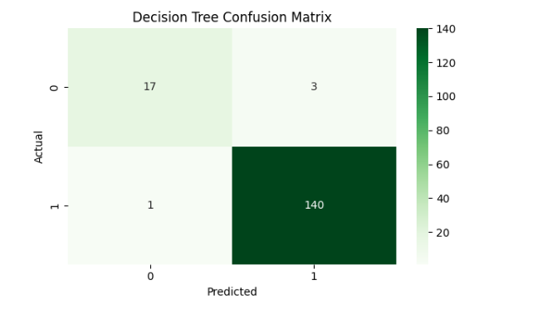
Figure 4.11: Confusion matrix of the Decision Tree model.

4.4.3 Random Forest
The Random Forest classifier combines multiple decision trees to improve prediction performance and reduce overfitting. The model achieved excellent results and demonstrated strong generalisation capability.
Table 4.9: Random Forest Performance
Metric | Value
Accuracy | 98.14%
Precision | 99.29%
Recall | 98.58%
F1-Score | 98.93%
The confusion matrix for the Random Forest model is shown below:
Actual / Predicted | Legitimate (0) | Suspicious (1)
Legitimate (0) | 19 | 1
Suspicious (1) | 2 | 139
The results indicate that the Random Forest model can effectively distinguish between legitimate and suspicious packages with a very low error rate.
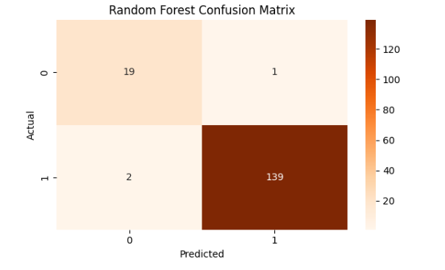
Figure 4.12: Confusion matrix of the Random Forest model.

4.5 Model Comparison
Table 4.10 compares the performance of the three machine learning models used in this study.
Table 4.10: Comparison of Machine Learning Models
Model | Accuracy | Precision | Recall | F1-Score
Logistic Regression | 96.27% | 98.56% | 97.16% | 97.86%
Decision Tree | 98.76% | 98.60% | 100.00% | 99.30%
Random Forest | 98.14% | 98.59% | 99.29% | 98.94%
The Decision Tree classifier achieved the highest overall performance, with an accuracy of 98.76% and an F1-score of 99.30%. The Random Forest model also demonstrated excellent performance, while Logistic Regression produced slightly lower results but still achieved an accuracy above 96%.These findings suggest that lightweight metadata and package similarity features can effectively detect software supply chain attacks without requiring source code analysis or runtime behavioural information.

4.5 Model Comparison
Figure 4.13 compares the classification accuracies of the three machine learning models evaluated in this study. All models achieved high performance, with accuracies exceeding 96%, indicating that package metadata and similarity features are effective for detecting suspicious packages.
The Decision Tree classifier achieved the highest accuracy of 98.76%, followed by the Random Forest model with an accuracy of 98.14%. Logistic Regression produced the lowest accuracy at 96.27%, although its performance remained strong and demonstrated the effectiveness of the selected features.
The results suggest that tree-based models are better suited to capturing the non-linear relationships between package metadata features and malicious package characteristics. However, the relatively small differences in accuracy indicate that all three models are capable of performing lightweight pre-installation detection of software supply chain attacks.
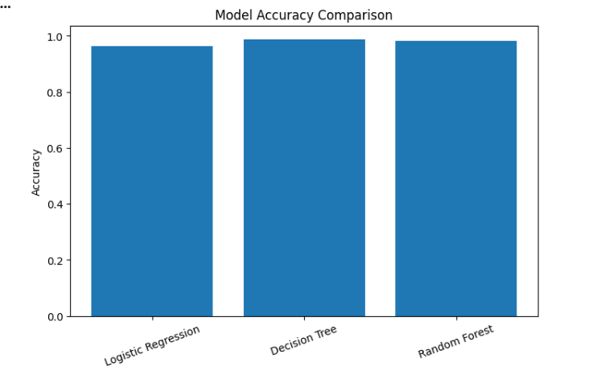
Figure 4.13: Model accuracy comparison.

4.6 ROC Curve Analysis
Receiver Operating Characteristic (ROC) curves were generated to evaluate the ability of the machine learning models to distinguish between legitimate and suspicious packages across different classification thresholds. The ROC curve plots the True Positive Rate (TPR) against the False Positive Rate (FPR), while the Area Under the Curve (AUC) provides an overall measure of model performance.
Table 4.11: Area Under the Curve (AUC) Results
Model | AUC Score
Logistic Regression | 0.993
Decision Tree | 0.921
Random Forest | 0.994
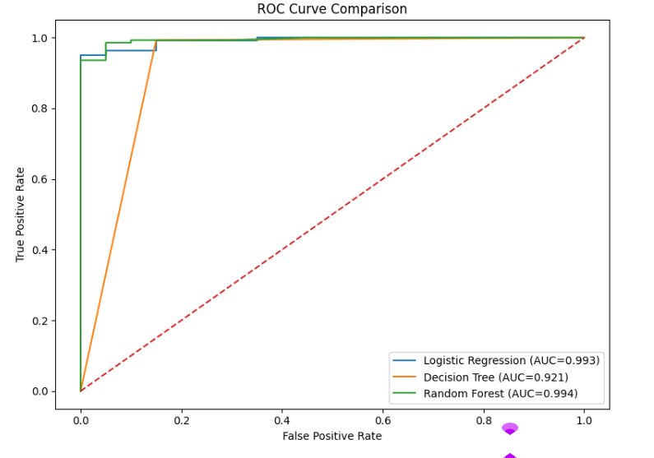
Figure 4.14: ROC curve comparison of the evaluated machine learning models.
The Logistic Regression model achieved an AUC score of 0.993, indicating excellent classification performance and a strong ability to distinguish between legitimate and suspicious packages.
The Decision Tree model achieved an AUC score of 0.921. Although this result is slightly lower than the other models, an AUC above 0.90 still demonstrates excellent discriminatory capability.
The Random Forest classifier produced the highest AUC score of 0.994, indicating superior classification performance and excellent generalisation capability.
Overall, all three models achieved AUC scores above 0.90, demonstrating that lightweight metadata and package similarity features are highly effective for detecting suspicious packages without requiring source code analysis or runtime behavioural information.

4.7 Feature Importance Analysis
Feature importance analysis was performed using the Random Forest classifier to determine the contribution of each feature to the detection of suspicious packages. Understanding the importance of individual features helps identify the characteristics that most strongly influence the classification process.
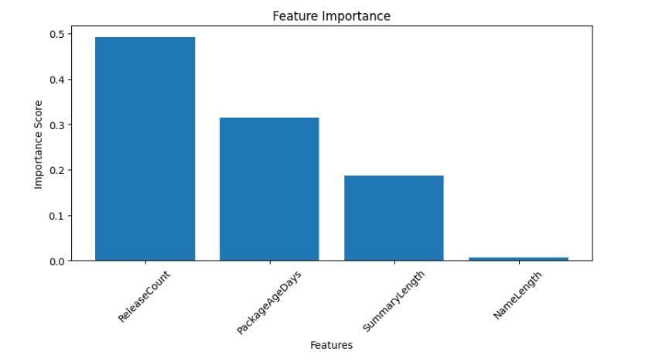
Figure 4.15: Feature importance scores obtained from the Random Forest model.
The results indicate that ReleaseCount is the most important feature, with an importance score of approximately 0.49. This suggests that the number of package releases is a strong indicator for distinguishing between legitimate and suspicious packages.
The second most important feature is PackageAgeDays, with an importance score of approximately 0.31. Older packages generally have a longer history and greater community trust, whereas newly created packages may be more likely to be associated with malicious activity.
SummaryLength achieved an importance score of approximately 0.19, indicating that the length of the package description provides additional information for the classification process.
Finally, NameLength contributed very little to the model, with an importance score close to zero. This suggests that package name length alone is not a strong predictor of malicious behaviour and should be considered together with other metadata features.
Table 4.12: Random Forest Feature Importance Scores
Feature | Importance Score
ReleaseCount | 0.49
PackageAgeDays | 0.31
SummaryLength | 0.19
NameLength | 0.01
The feature importance analysis demonstrates that repository metadata provides valuable information for the early detection of suspicious packages. In particular, package release history and package age appear to be the most influential indicators in the proposed lightweight detection framework.

4.8 External Validation Using OpenSSF Dataset
To evaluate the generalisability of the proposed framework, an external validation experiment was conducted using real malicious packages obtained from the OpenSSF malicious package repository. Unlike the synthetic typosquatting dataset used during model development, the OpenSSF repository contains real-world malicious packages that have been identified and reported by the open-source security community.
A random sample of 100 malicious packages was selected from the OpenSSF dataset for external testing. Metadata features were extracted from the selected packages and transformed into the same format used during model training.
Table 4.13: External Validation Dataset
Item | Value
Source | OpenSSF Malicious Package Repository
Packages Sampled | 100
Features Used | NameLength, SummaryLength, ReleaseCount, PackageAgeDays
Purpose | External model validation
The trained Random Forest model was then applied to the external dataset.
Table 4.14: External Validation Results
Metric | Value
Packages Tested | 100
Packages Detected as Suspicious | 100
Detection Rate | 100.0%
The model successfully classified all 100 sampled malicious packages as suspicious, resulting in a detection rate of 100%.
The external validation results suggest that the proposed framework is capable of identifying real malicious packages and is not solely learning the patterns generated by the synthetic training data. This finding provides evidence that the metadata-based approach can generalise beyond the synthetic dataset and may be suitable for practical software supply chain attack detection.
However, this result should be interpreted cautiously. The external validation dataset consisted exclusively of malicious packages and represented only a subset of the complete OpenSSF repository. Additional experiments using larger and more diverse datasets, including both legitimate and malicious packages, are recommended in future work to further evaluate the robustness and generalisability of the proposed framework.
The external validation experiment demonstrates encouraging results; however, the perfect detection rate should be interpreted carefully because the evaluation was performed on a relatively small sample of malicious packages and did not include legitimate packages from external sources. Therefore, further validation using larger and more diverse datasets is required.
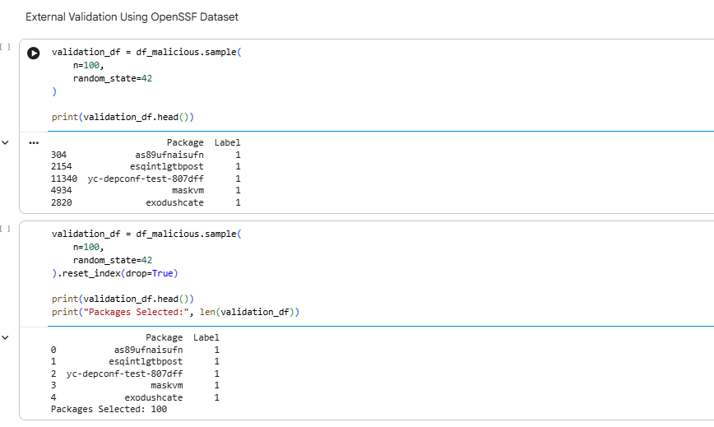
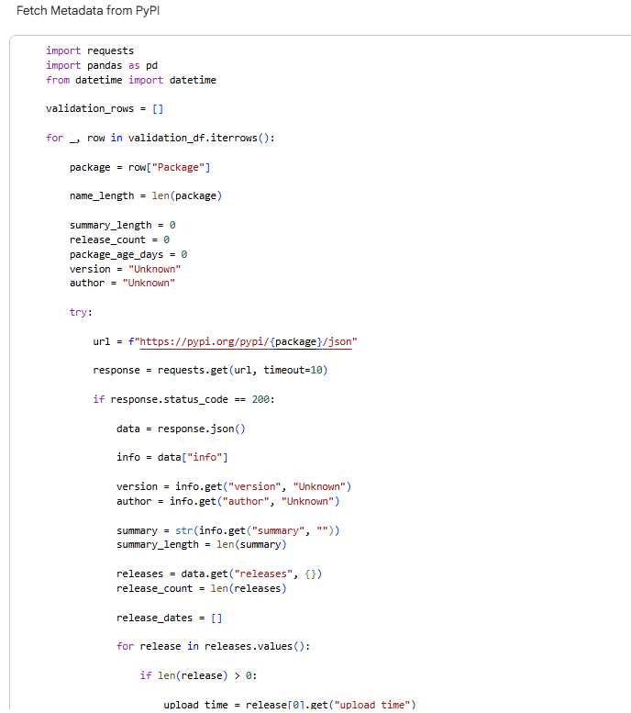
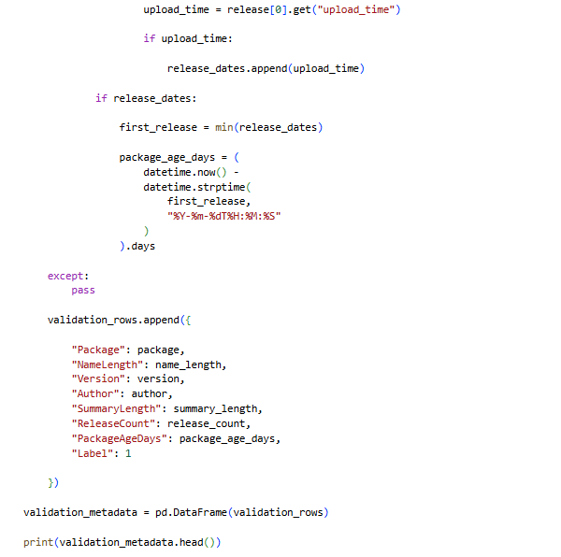

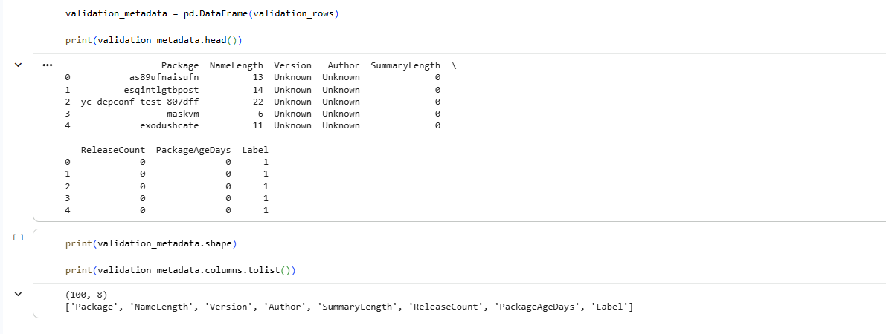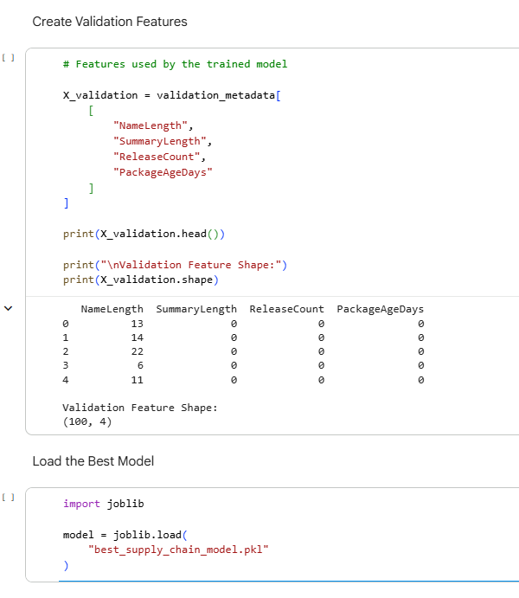
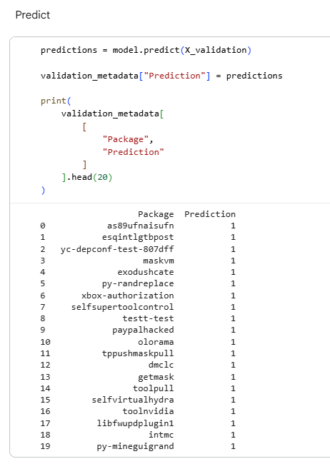
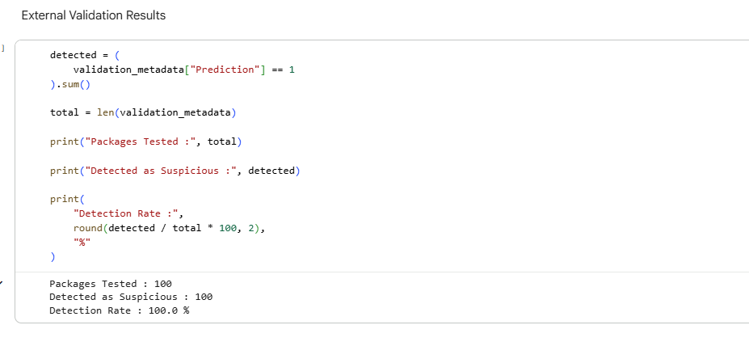
Figure 4.18: External validation results showing the overall detection rate.

4.9 Discussion

4.9.1 Overall Model Performance
The experimental results demonstrate that machine learning techniques can effectively identify suspicious packages using lightweight metadata features. All three models achieved classification accuracies above 96%, indicating that package metadata and similarity information provide sufficient information for distinguishing between legitimate and suspicious packages.
The high performance achieved by the models suggests that early-stage detection of software supply chain attacks is possible without requiring source code analysis or dynamic behavioural monitoring. This finding supports the main objective of this research, which is to develop a lightweight pre-installation detection framework.

4.9.2 Comparison of Machine Learning Models
Among the evaluated models, the Decision Tree classifier achieved the highest classification accuracy of 98.76% and the highest F1-score of 99.30%. The Random Forest model achieved a slightly lower accuracy of 98.14% but produced the highest AUC score of 0.994, indicating excellent discriminatory capability across different classification thresholds.
Logistic Regression achieved the lowest performance among the three models, although it still obtained an accuracy above 96%. Overall, the results indicate that tree-based models are more effective for modelling the non-linear relationships between package metadata features and suspicious package characteristics.

4.9.3 Importance of Metadata Features
Feature importance analysis revealed that ReleaseCount and PackageAgeDays were the most influential features in the classification process. These findings suggest that newly created packages with limited release histories may be more likely to exhibit malicious characteristics.
SummaryLength also contributed to the detection process, whereas NameLength had very little impact on model performance. This indicates that package metadata provides meaningful information for identifying suspicious packages and can be effectively used for lightweight software supply chain attack detection.

4.9.4 External Validation Findings
To address concerns regarding the use of synthetic data, an external validation experiment was conducted using real malicious packages obtained from the OpenSSF malicious package repository. The trained model successfully identified all 100 sampled malicious packages as suspicious, resulting in a detection rate of 100%.
These findings provide preliminary evidence that the proposed framework is capable of generalising beyond the synthetic training dataset and may be applicable in real-world software supply chain security scenarios.

4.9.5 Limitations
Although the experimental results are encouraging, several limitations should be acknowledged. First, the training dataset relied heavily on synthetically generated typosquatting packages. This may introduce a circular evaluation problem because the machine learning models could partially learn patterns generated during dataset construction rather than the full diversity of real-world attacks.
Second, the external validation experiment used only a sample of malicious packages from the OpenSSF repository and did not include additional legitimate packages from external sources. Consequently, the reported detection rate should be interpreted cautiously.
Finally, the study focused exclusively on metadata-based detection and did not consider source code analysis or runtime behavioural information. Future work should therefore incorporate larger and more diverse datasets and investigate hybrid approaches that combine metadata, static code analysis and behavioural features to further improve the robustness and generalisability of the proposed framework.
Although external validation using OpenSSF packages improves confidence in the framework, the model was validated using only a small sample of real malicious packages and further evaluation using larger and more diverse datasets is required.

Chapter 5: Conclusion and Future Work

5.1 Conclusion
This study proposed a lightweight machine learning framework for detecting software supply chain attacks in open-source ecosystems. The framework utilised package metadata and similarity analysis to identify suspicious packages associated with dependency confusion and typosquatting attacks.
A dataset was constructed using legitimate packages collected from the PyPI repository and synthetically generated suspicious packages. Three machine learning models, namely Logistic Regression, Decision Tree and Random Forest, were trained and evaluated using the constructed dataset.
The experimental results demonstrated that all three models achieved high classification performance, with accuracies above 96%. The Decision Tree classifier achieved the highest accuracy, while the Random Forest model achieved the highest AUC score. Feature importance analysis showed that ReleaseCount and PackageAgeDays were the most influential features in the detection process.
To address the limitations of synthetic data, external validation was performed using real malicious packages obtained from the OpenSSF malicious package repository. The results demonstrated encouraging performance and indicated that the proposed framework has the potential to generalise to real-world software supply chain attack scenarios.
Overall, the findings suggest that lightweight metadata-based approaches can effectively support the early detection of suspicious packages without requiring source code analysis or runtime behavioural monitoring.

5.2 Contributions of the Study
The main contributions of this research are as follows:
- Development of a lightweight framework for the early detection of software supply chain attacks.
- Investigation of metadata and package similarity features for malicious package detection.
- Comparative evaluation of multiple machine learning models.
- Identification of important metadata features influencing package classification.
- External validation using real malicious packages from the OpenSSF reposi

5.3 Future Work
Although the proposed framework produced encouraging results, several opportunities exist for future research:
- Validate the framework using larger and more diverse datasets containing both legitimate and malicious packages.
- Investigate additional metadata and behavioural features to improve model performance.
- Explore advanced machine learning and deep learning techniques for package classification.
- Develop a real-time monitoring system for analysing newly published packages on PyPI.
- Implement an interactive Streamlit dashboard for package analysis and risk visualisation.
- Integrate the framework with software development tools and package management systems to support practical deployment.
Future work will focus on extending the proposed framework into a real-time software supply chain security platform capable of continuously monitoring package repositories and providing early warnings for potentially malicious packages.

References
Adem, A., Erman Çakıt, Metin Dağdeviren, Mrugalska, B. and Karwowski, W. (2026). Understanding security challenges in the software supply chain through causal relationships. PLoS ONE, 21(3), pp.e0344098–e0344098. doi: https://doi.org/10.1371/journal.pone.0344098.
Amft, S., Höltervennhoff, S., Panskus, R., Marky, K. and Fahl, S. (2024). Everyone for Themselves? A Qualitative Study about Individual Security Setups of Open Source Software Contributors. 2022 IEEE Symposium on Security and Privacy (SP), [online] 17(Date of Conference: 19-23 May 2024), pp.1065–1082. doi: https://doi.org/10.1109/sp54263.2024.00214.
Cox, R. (2025). Fifty Years of Open Source Software Supply Chain Security. Queue, 23(1), pp.84–107. doi: https://doi.org/10.1145/3722542.
Gokkaya, B., Aniello, L. and Halak, B. (2025). Software supply chain: A taxonomy of attacks, mitigations and risk assessment strategies. Journal of Information Security and Applications, [online] 97(104324), p.104324. doi: https://doi.org/10.1016/j.jisa.2025.104324.
Halder, S., Bewong, M., Arash Mahboubi, Jiang, Y., Islam, M.R., Islam, M.Z., Ip, R.H., Ahmed, M.E., Ramachandran, G.S. and Babar, M.A. (2024). Malicious Package Detection using Metadata Information. Proceedings of the ACM Web Conference 2022, May 13–17(ISBN 979-8-4007-0171-9/24/0), pp.1779–1789. doi: https://doi.org/10.1145/3589334.3645543.
Huang, Y., Wang, R., Zheng, W., Zhou, Z., Wu, S., Ke, S., Chen, B., Gao, S. and Peng, X. (2024). SpiderScan: Practical Detection of Malicious NPM Packages Based on Graph-Based Behavior Modeling and Matching. SpiderScan: Practical Detection of Malicious NPM Packages Based on Graph-Based Behavior Modeling and Matching, 26(Pages 1146 - 1158), pp.1146–1158. doi: https://doi.org/10.1145/3691620.3695492.
Jallow, A., Schilling, M., Backes, M. and Bugiel, S. (2024). Measuring the Effects of Stack Overflow Code Snippet Evolution on Open-Source Software Security. 2024 IEEE Symposium on Security and Privacy (SP), Date of Conference: 19-23 May 2024(ISBN:979-8-3503-3131-8), pp.1083–1101. doi: https://doi.org/10.1109/sp54263.2024.00022.
Lew, K., Sarker, A., Wuthier, S., Kim, J., Kim, J. and Chang, S.-Y. (2024). Distributed Software Build Assurance for Software Supply Chain Integrity. Applied Sciences, 14(20), p.9262. doi: https://doi.org/10.3390/app14209262.

Li, K., Zhang, J., Chen, S., Liu, H., Liu, Y. and Chen, Y. (2024). PatchFinder: A Two-Phase Approach to Security Patch Tracing for Disclosed Vulnerabilities in Open-Source Software. Proceedings of the 33rd ACM SIGSOFT International Symposium on Software Testing and Analysis, Pages 590 - 602(Published: 11 September 2024), pp.590–602. doi: https://doi.org/10.1145/3650212.3680305.
None Olubunmi Adeolu Adenekan, None Chinedu Ezeigweneme and None Excel Great Chukwurah (2024). Strategies for protecting IT supply chains against cybersecurity threats. International journal of management & entrepreneurship research, 6(5), pp.1598–1606. doi: https://doi.org/10.51594/ijmer.v6i5.1125.
Schorlemmer, T.R., Kalu, K.G., Chigges, L., Ko, K.M., Ishgair, E.A., Bagchi, S., Torres-Arias, S. and Davis, J.C. (2024). Signing in Four Public Software Package Registries: Quantity, Quality, and Influencing Factors. 2024 IEEE Symposium on Security and Privacy (SP), 19-23 May 2024(05 September 202), pp.1160–1178. doi: https://doi.org/10.1109/sp54263.2024.00215.
Shiri Harzevili, N., Boaye Belle, A., Wang, J., Wang, S., Jiang, Z.M. (Jack) and Nagappan, N. (2024). A Systematic Literature Review on Automated Software Vulnerability Detection Using Machine Learning. ACM Computing Surveys, Volume 57(Issue 3). doi: https://doi.org/10.1145/3699711.
Vu, M.-K., Nguyen, T.-C. and Vu, D.-L. (2025). POSTER:TYPOSQUATTING ATTACKS ON THE RUST ECOSYSTEM. Proceedings of the 20th ACM Asia Conference on Computer and Communications Security, ASIA CCS ’25(Pages 1791 - 1793), pp.1791–1793. doi: https://doi.org/10.1145/3708821.3735340.
Wang, J., Li, Z., Qu, J., Zou, D., Xu, S., Xu, Z., Wang, Z. and Jin, H. (2025). MalPacDetector: An LLM-based Malicious NPM Package Detector. IEEE Transactions on Information Forensics and Security, [online] Volume: 20(Page(s): 6279 - 6291), pp.1–1. doi: https://doi.org/10.1109/tifs.2025.3580336.
Williams, L., Benedetti, G., Hamer, S., Ranindya Paramitha, Rahman, I., Mahzabin Tamanna, Tystahl, G., Nusrat Zahan, Morrison, P., Acar, Y., Cukier, M., Kästner, C., Alexandros Kapravelos, Dominik Wermke and Enck, W. (2025). Research Directions in Software Supply Chain Security. ACM Transactions on Software Engineering and Methodology, Vol. 34(No. 5). doi: https://doi.org/10.1145/3714464.
Williams, L., Hamer, S. and Zahan, N. (2025). Can the Rising Tide of Software Supply Chain Attacks Raise All Software Engineering Boats? Proceedings of the 33rd ACM International Conference on the Foundations of Software Engineering, Pages 18 - 26(Published: 28 July 2025), pp.18–26. doi: https://doi.org/10.1145/3696630.3734200.
Wu, S., Song, W., Huang, K., Chen, B. and Peng, X. (2024). Identifying Affected Libraries and Their Ecosystems for Open Source Software Vulnerabilities. Identifying Affected Libraries and Their Ecosystems for Open Source Software Vulnerabilities, Article No.: 162(Published: 12 April 2024). doi: https://doi.org/10.1145/3597503.3639582.
Zhang, J., Huang, K., Huang, Y., Chen, B., Wang, R., Wang, C. and Peng, X. (2024). Killing Two Birds with One Stone: Malicious Package Detection in NPM and PyPI using a Single Model of Malicious Behavior Sequence. ACM Transactions on Software Engineering and Methodology, Vol. 34(No. 4). doi: https://doi.org/10.1145/3705304.
Zhou, S., Li, H., Fu, X. and Jiao, Y. (2024). A Novel Malware Detection Model in the Software Supply Chain Based on LSTM and SVMs. Applied Sciences, 14(15), p.6678. doi: https://doi.org/10.3390/app14156678.

